**Game Design Document – EMC (Untitled)**

Version 1.0

August 01, 2022

© 2022 EMC Productions

**Revision List**

|  |  |  |  |
| --- | --- | --- | --- |
| **Version** | **Author** | **Date** | **Comments** |
| 1.00 | K.N Rezaga | August 07, 2022 | Initial Version |
|  |  |  |  |
|  |  |  |  |
|  |  |  |  |
|  |  |  |  |
|  |  |  |  |
|  |  |  |  |

**Table of Contents**

1. Introduction………………………………………………………………………………………………………………………………………………………………………..4

1.1 Scope……………………………………………………………………………………………………………………………………………………………………….4

1. References………………………………………………………………………………………………………………………………………………………………………...4
2. Target System……………………………………………………………………………………………………………………………….………………………………….5

3.1 PC…………………………………………………………………………………………………………………………………………………………………………….5

1. Development System……………………………………………………………………………………………………………………………………………………..5

4.1 Software……………………………………………………………………………………………………………………………………………………………….5

1. Specification………………………………………………………………………………………………………………………………………………………………………6

5.1 Concept

5.2 Story

5.3 Game Structure

5.4 Players

5.5 Action

5.6 Objective

5.7 Graphics

1. Gameplay
2. Front End

7.1 Intro

7.2 Menus

1. Development Tools
2. Team
3. Time (Gantt Chart)

**0**

**1. Introduction**

This game document specifies a design for the gameplay of a game entitled “[Insert Title]“. The contents of this document are based on things discussed in various meetings held since 1st August 2022 and involving Ivan Ralph Estrera, Jan Christian Buan, Kristian Nicolas Rezaga, Angelo Moreno, Jay Mclein Evaristo, Franc Paul Rivera, Rayden Karl Palmenco, Johanna Stephanie Benedicto, and Lois Eunice Rufa.

**1.1 Scope**

This game design document is intended to be read by programmers, artists, and producers involved in the design, implementation, and testing of “[Insert Title]”.

**2. References**

**3. Target System**

“[Insert Title]” will be produced for PC. This document is primarily concerned with the PC version.

**3.1 PC**

As of the moment, only PC version would be developed. System preferences would be based upon the game engine that the developers would use.

**4. Development System**

**4.1 Software**

“[Insert Title]” will use the game engine “Unity” developed by Unity Technologies.

**5. Specification**

**5.1 Concept**

The aim of “[Insert Title]” is to produce a fun, addictive, and nostalgic multi-player/coop game which uses ragdoll physics combined with party games.

**5.2 Story**

**5.2.1 Setting**

**5.3 Game Structure**

Inspired by games such as Fall Guys and Gang Beasts. There would be different Filipino classic games inspired with a twist combined with other usual type of party games. This is so that players would have different interesting choices to play with while maintaining that nostalgic vibes through indulging them with their all-time favorite classic Filipino games.

**5.4 Players**

The PC game will be playable by multiple players (maximum of 10) across a network.

**5.5 Action**

Players will be able to play through a variety of party games (which are randomly selected) in which some of those are all time classic Filipino games with a twist. The mechanics of each would be based upon on what type of party game is selected by the system.

**5.6 Objective**

The objective of the game will vary depending on the type of party game that was selected. No elimination would occur between the players and the winner would be determined through the points accumulated in each round. The player has the chance to play one of [how many games] party games in each round:

**5.6.1 Tug of War**

**5.6.2 King of the Hill**

**5.6.3 Find the right Door**

**5.6.4 Escape the Chicken**

**5.6.5 Dodge the rolling Rocks**

**5.6.6 Musical Chair**

**5.6.7 Bring Me**

**5.6.8 Whisper Down Lane**

**5.7 Graphics**

**5.7.1 Orientation**

The game would be played in a 3rd person point of view.

**5.7.2 Design**

The game features a Ghibli Style type of design.

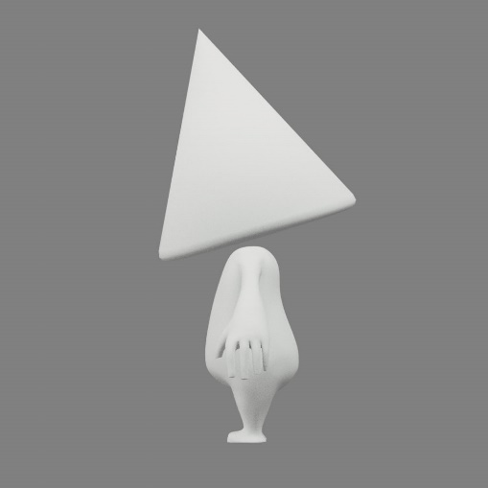 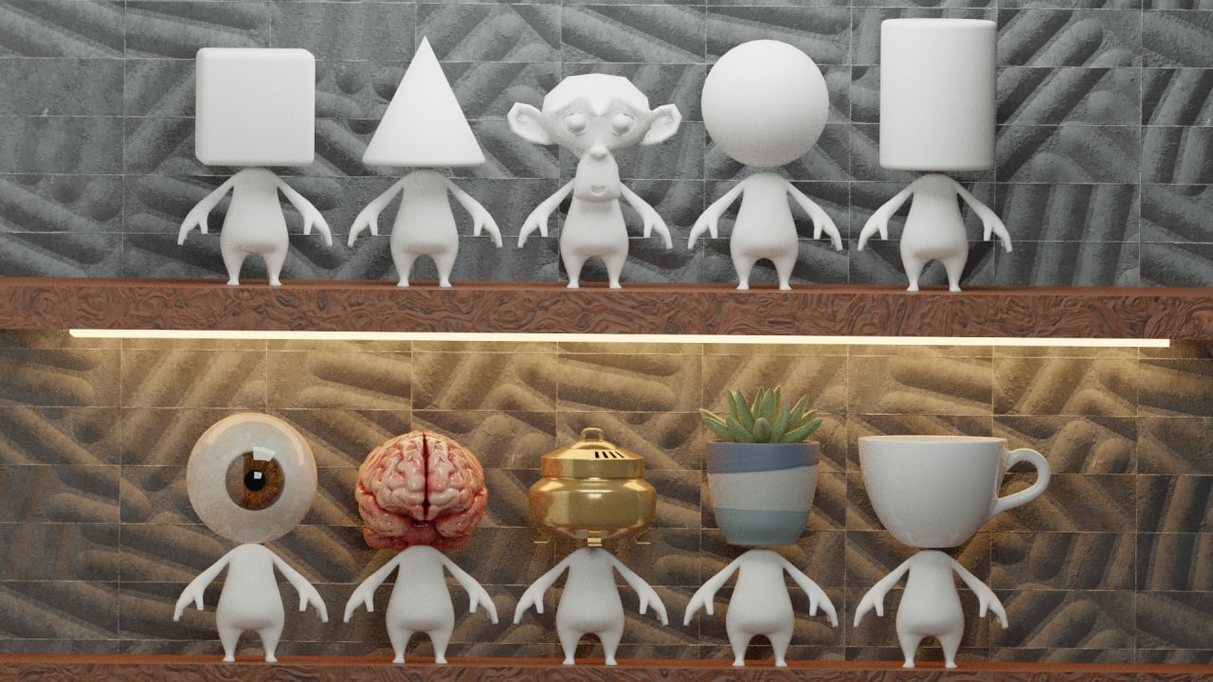

(Earlier Prototypes of Character Models)

**6. Gameplay**

**7. Front End**

**7.1 Intro**

**7.2 Menus**

**8. Development Tools**

**8.1 Editor**

**9. Team**

Project Manager : Kristian Nicolas Rezaga

Programmers/Developers : Ivan Ralph Estrera | Jan Christian Buan

Artists/Designers : Angelo Moreno | Jay Mclein Evaristo

Lois Eunice Rufa | Rayden Karl Palmenco

Sound Design/Production : Franc Paul Rivera

UI/UX Design : Johanna Stephanie Benedicto

**10. Time**

Official Start Date : August 01, 2022

Complete Game Design :

Milestone 1 – :

Milestone 2 - :

Milestone 3 - :

Milestone 4 - :

End of Project : December 2022 (Proposed)

